Name: __________________________ Due: _______________

3A/3B HUMAN BIOLOGICAL SCIENCE
INVESTIGATION 1
BODY PROPORTIONS

Rationale
Scientists often gather statistics to find a relationship between the size, shapes and densities of organs body structures. This information can be used to support hypotheses and allow confident predictions to be made.

Areas including forensics, anthropology, sport science and nutrition all measure anatomical structures to provide diagnosis, answer questions or predict unknowns. Artists and fashion designers also need to be familiar with body proportions. They use ratios to guide their illustrations and clothing sizes.

In genetics, many genes play a role in determining our physical appearance as well as the influence of our surroundings. Height and body mass is used to calculate the Body Mass Index. Lengths of femurs can be used to predict a person’s height.

Task
You are to investigate a relationship between structures of the human body, and collect data in way that is valid, reliable and ethical.

Valid in terms of making sure the investigation tested what it set out to.

Reliable in terms of a procedure explicit enough for the experiment to be replicated with similar results expected, results are said to be stable and consistent. A test is considered reliable if you get the same result repeatedly.

Ethical in terms of protecting the privacy, physical and emotional safety of the participants.

Choose any two of the following and attempt to find a relationship between them:
- head circumference
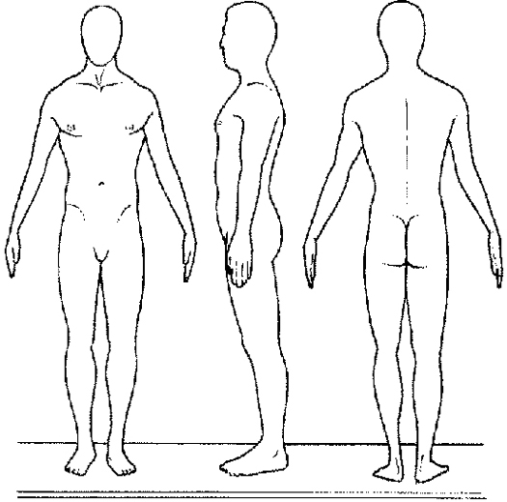
- knee to upper ankle
- upper ankle to heel base
- position of belly button to elbow
- chin to sternum
- sitting height
- bi-acromial breadth
- upper am circumference
- head length
- head breadth
- bi-zygomatic breadth
- total facial height

NB
No two students are to use the same pair of measurements.
Your teacher must approve other suggested measurements.

Image obtained from: http://content.answers.com/main/content/img/oxford/Oxford_Sports/0199210896.somatotype.1.jpg
Lab Report Format

Your investigation will be presented in the form of a written report. (A typed copy is preferred). Adhere to the guidelines regarding format – marks will be deducted if it is not followed.

STYLE & TONE
Your lab report should be written in the “third person”. No “I” or “my”. It should also not contain emotive language. A report is about facts supported claims - not feelings. If your report is typed, use a font such as Times with a size of 12.

STRUCTURE
Your report must include:
- Headings: Introduction, Materials, Method, Results, Discussion and References.
- Introduction:
  - Is a summary of what you were investigating
  - States what you hope to find,
  - Discuss relevant background information
  - Ends by stating your hypothesis.

- Materials:
  - A list of items used

- A Method that includes:
  - general details on participants (age, gender, how they were selected),
  - ethical considerations behind your method of data collection
  - how you controlled other variables (mention at least 3)
  - describe step-by-step how you actually went about collecting the data
  - (this must be written like a recipe so another scientist can reproduce your experiment)

- Results, that include:
  - a table
  - a graph
  - observations
  - analysis of data should include mean averages, and a description of the range of measurements.
  - a description of any trends you discovered.

- Discussion
  - states whether your hypothesis was supported or not with evidence from your data
  - summarises your findings
  - offer criticism of the techniques used
  - highlights limitations and provides suggestions for improvement
  - suggests other related areas that should be researched.

- References:
  - Acknowledgement of the research by others you have used to guide your own investigation.

For further details on how to write your report, see pages 15-16 of Human Perspectives Book 2 5th Edition.
HYPOTHESES & VARIABLES

A HYPOTHESIS is a testable statement about a single idea. It is a guess about how something works.

The way a hypothesis is worded can tell you the variables involved; that is, the thing being tested or deliberately changed (independent variable) and the thing being measured (dependant variable).

For example:

It is hypothesised that males all have blue eyes.
(independent) (dependant)

It is hypothesised that the greater the altitude of an aeroplane, the greater the anxiety felt by passengers
(independent) (dependent)

It is hypothesised that the lower the temperature, the denser a liquid will become.
(independent) (dependent)

You may note that a hypothesis often involves a description of magnitude ie, greater, decrease, all, higher, lower, increase, less.

DATA

There are 2 types of data you can collect:
Discrete (or qualitative) and continuous (or quantitative)

Discrete data is if there are only a finite number of possible values.
(eg “yes”/”no”, “blue”/”red”/”yellow”, “loud”/”not loud”)

Continuous data is usually data that has a larger range of possible values. It is usually collected from variables that can be measured numerically (time, mass, temperature, speed etc)
Displaying Your Results As A Graph Or Table

Rules for graphing
- Must be done in pencil
- Must have a title at the top that describes what it is graphing.
- Include a key if needed
- Must have ruled axes (with a ruler!)
- Axes must have labels & units
- Start at zero
- Indicate if you are “breaking the axis”
- Must have an even scale
- Use 2/3’s of the space you are given
- Use a line graph if the data is continuous (esp. over time)
- Use a column graph is the data is discrete.
- Independent variable is on the horizontal (x) axis
- Must NOT join the graph to the axis unless there is a value of zero, or unless the axes have been “broken”
- Graph the mean average if multiple samples have been taken.
- Join dots of a line graph (NOT if it is a scattergraph)
- *(scattergraphs should include a line of best fit)

Rules for tabulating data
Age and blood pressure of employees
- Use pencil
Age (x) | Systolic blood pressure (y)
37.2 | 133
39.8 | 143
42.1 | 135
44.6 | 151
47.2 | 143
48.9 | 158
50.0 | 163
51.3 | 146
52.8 | 168
54.4 | 160
- Give a descriptive heading
- If listing data downwards, the independent variable will be on the left.(x)
- If listing data horizontally, the independent variable will be on the top (x)
- Rule lines with ruler

